BharatVoice AI: A Multilingual Voice Assistant for Grounded, Everyday Citizen Services in Five Indian Languages
Sri Ram Rajendrakumar R  Dept. of AI&ML  Vels Institute of Science, Technology and Advanced Studies (VISTAS)  Chennai, Tamil Nadu, India | Jonathan David D  Dept. of AI&ML  Vels Institute of Science, Technology and Advanced Studies (VISTAS)  Chennai, Tamil Nadu, India | Joe Anto Prakash J  Dept. of AI&ML  Vels Institute of Science, Technology and Advanced Studies (VISTAS)  Chennai, Tamil Nadu, India | Ms. VP. Anitha  Dept. of AI&ML  Vels Institute of Science, Technology and Advanced Studies (VISTAS)  Chennai, Tamil Nadu, India
*Corresponding author.
Abstract—A lot of people in India would sooner ask a question out loud in Tamil, Hindi, Telugu or Kannada than dig through an English government portal. When they do type, it is often in Roman letters with English words mixed in. We built BharatVoice AI for these users. It is a web assistant that covers a small, fixed set of everyday needs: what an identity document is and where to get it, emergency numbers, weather, mandi crop prices, reminders, sums and unit conversion, and a question bank with cited answers on banking, online fraud, welfare schemes, travel, education, jobs and hospitals. There is no large language model anywhere in the system. Speech is captured in the browser, and the FastAPI backend handles each request with rules first. A four-stage cascade picks the language, emergency requests are matched before any classifier is consulted, and every factual reply either names its source or says that the assistant does not know. This version also adds optional sign-in with per-user history, Alembic migrations, reminders that arrive through Web Push after the tab is closed, and helpline numbers that can be tapped to call. All 693 backend tests and 45 frontend tests pass. Those tests check behaviour, not recognition accuracy, so we also lay out how accuracy should be measured, and we report a short hands-on probe in which romanized questions exposed several real gaps.
Keywords—Indian languages; voice user interface; code-mixed text; language identification; citizen services; grounded response generation; selective prediction; web push notifications.
I. Introduction
More and more public services in India are offered through websites and apps, and most of them expect the visitor to read English or Hindi, find their way through several levels of menus, and type a search query. Think of a farmer in Madurai who wants to know where to get an Aadhaar record corrected, or a retired teacher in Mysuru who has just had an odd phone call about her bank account. Neither may be comfortable with any of those steps. Studies of interfaces for low-literate users found long ago that speech and simple visual cues help [1], and city-level chatbot deployments suggest that people will use a conversational channel if one exists [2]. The parts needed to build such a channel for Indian languages are now openly available: speech recognisers [3]–[6], pretrained Indian-language encoders [7]–[9], translation for all 22 scheduled languages [10], and the national BHASHINI platform [11].
When we started putting these parts together, two problems came up again and again. The first was the way people actually type. “PAN card kaise banaye”, which is Hindi for “how do I get a PAN card”, is written entirely in Latin letters and has an English noun in the middle. A script check sees only ASCII, and a general-purpose language identifier, trained mostly on single-language text, usually decides it is English. The reply then comes back in the wrong language. Identifying romanized Indic text is still an open research problem [12], and benchmarks on code-switched text show that standard models lose a good deal of accuracy on it [13], [14].
The second problem was trust. If someone asks about a government document, a scheme or a helpline and gets a wrong answer, they may make a wasted trip to an office or pay a fee they did not owe. A confident reply in the user’s own language makes such a mistake harder to notice. Text generators are known to state things that no source supports [15]. Retrieval-augmented generation [16] and attribution checks [17] help, but most of that work is on English and on encyclopaedia-style questions.
Our answer to both problems was to keep every decision simple enough to inspect, and to let the assistant say “I don’t know”. The paper describes five pieces of that design. First, every heavy component has a light stand-in, so the whole system runs on a normal laptop with no GPU. Second, language is identified by a cascade whose rules and thresholds we write out in full. Third, emergency requests are taken out of the classifier’s hands, and a trained model is only trusted above a fixed confidence. Fourth, the source of a factual reply is part of the reply’s data type, and a missing source becomes a refusal. Fifth, history and reminders belong to an owner, guests keep their history when they sign up, and reminders can be pushed to the browser. We also describe how accuracy and refusal behaviour should be measured.
Section II covers related work. Sections III and IV describe the method and the prototype. In Section V we report what has been tested so far and set out the measurements that are still to be done. Section VI discusses the design and its limits, and Sections VII and VIII close the paper with conclusions and planned work. We do not report any recognition-accuracy numbers.
II. Related Work
A. Speech Recognition for Indian Languages
Whisper showed that a single model, trained on a huge amount of loosely labelled audio, can transcribe many languages without being tuned for each one [3]. Work focused on Indian languages has gone in three directions: self-supervised pretraining on roughly 17,000 hours of audio in forty languages [4], a shared benchmark with fine-tuned recognisers for twelve languages [5], and a collection of 7,348 hours of natural speech from 16,237 speakers [6]. These projects give us models and data. Running the larger models at conversational speed, though, usually needs a GPU, and a student team or a small district office often does not have one.
B. Language Representations and Identification
MuRIL saw transliterated text pairs as well as native-script text during pretraining, which is why it is often suggested for romanized input [7]. IndicNLPSuite and the later IndicBERT v2 added more languages and tasks [8], [9]. MASSIVE gives intent and slot labels for assistant commands in 51 languages [18], but it does not include romanized Indic text. On identification, IndicLID handles both native and romanized text for 22 languages, and its authors point out that romanized input remains hard because there is little labelled data and neighbouring languages are easy to confuse [12]. That remark is the reason our cascade (Section III-D) is allowed to say nothing rather than guess.
C. Code-Mixed and Transliterated Text
GLUECoS measured the drop in accuracy that standard models show on code-switched text across several tasks [13]. For Tamil, a hand-labelled corpus of Tamil–English social-media comments shows how freely people switch between the two [14]. Aksharantar released transliteration data and models for 21 Indic languages [19]. All three are datasets or benchmarks; none was built to sit inside a running assistant.
D. Grounded Answers and Selective Prediction
Ji et al. separate generated content that contradicts its source from content that the source never contained [15]. Retrieval augmentation gives the generator retrieved passages to work from [16], and Rashkin et al. ask whether each generated statement can be traced back to an identified source [17]. A much older idea fits our case well: Chow’s reject option, where a classifier may refuse to decide and so accepts lower coverage in exchange for fewer errors [20]. Geifman and El-Yaniv later applied the same trade-off to deep networks as selective classification [21]. We use this idea for whole answers instead of single labels.
E. Positioning of BharatVoice AI
Speech synthesis for Indian languages has also improved under low-resource conditions [22], so each stage of a voice assistant now has a usable open option. What we found less of in the literature is a complete, citizen-facing system that copes with romanized and code-mixed input, refuses when it has no source, and still runs on modest hardware. That combination is what this paper contributes. We have not measured whether it is more accurate than other designs, and we do not claim that it is.
III. Methodology
A. System Architecture and Design
Fig. 1 shows the overall layout. In the browser, the client draws the voice-first screen, records and plays speech, and registers a service worker so that it can receive notifications. On the server, FastAPI first works out who is calling. The natural-language understanding (NLU) pipeline then decides the language, the intent and the entities, and the request goes to one of four kinds of handler: local skills, curated content, live data adapters or the reminder store. Every handler’s output goes through the same response policy before anything is sent back. Underneath sits a SQLite database, accessed with SQLAlchemy and versioned with Alembic.
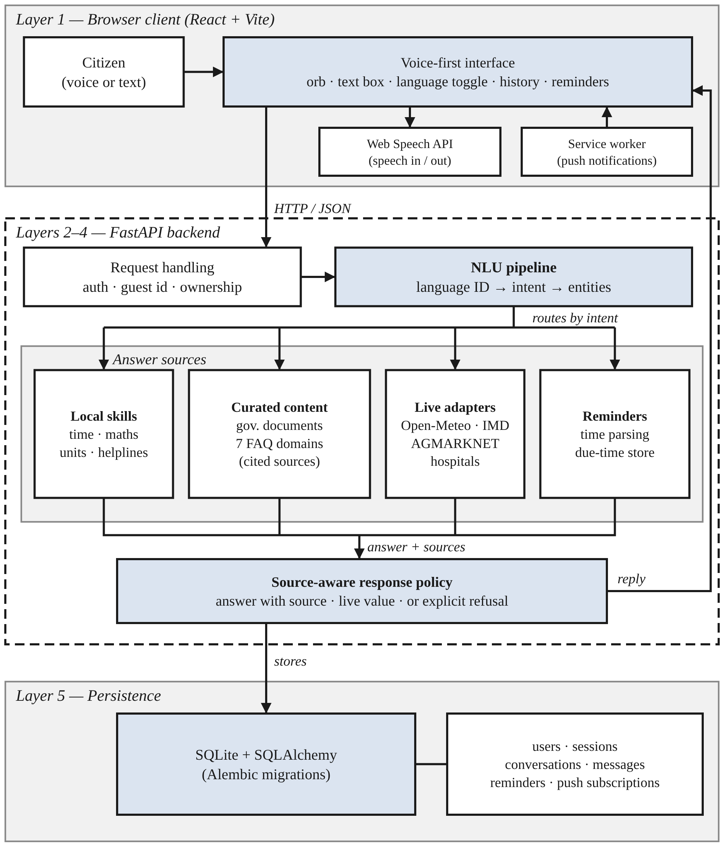
Fig. 1. Layered architecture of BharatVoice AI.
Two constraints drove most of the design. One was hardware. We wanted the system to run on an ordinary laptop with no GPU and without downloading several gigabytes of models, so every heavy component sits behind an interface that also has a light implementation (Table I). The light one is picked at start-up if the heavy one is not installed. Taking a model away makes answers weaker, but nothing crashes, and adding a model back is a configuration change. The other constraint was that we wanted to be able to explain any reply after the fact. For that reason the language, intent, entities and sources chosen for each message are saved with it.
TABLE I. Heavy components and their light substitutes
Stage | Full component | Light substitute (default)
Speech input | Whisper on the server | Browser Web Speech API
Language ID | MuRIL or IndicLID checkpoint | Script share and cue words
Intent | Fine-tuned MuRIL classifier | Ordered keyword and parse rules
Translation | IndicTrans2 | Curated Tamil–English dictionary
Speech output | BHASHINI or Coqui XTTS on the server | Browser speech synthesis, tried first
Fig. 2 traces one request through the system, and Sections III-B to III-I go through the steps in order.
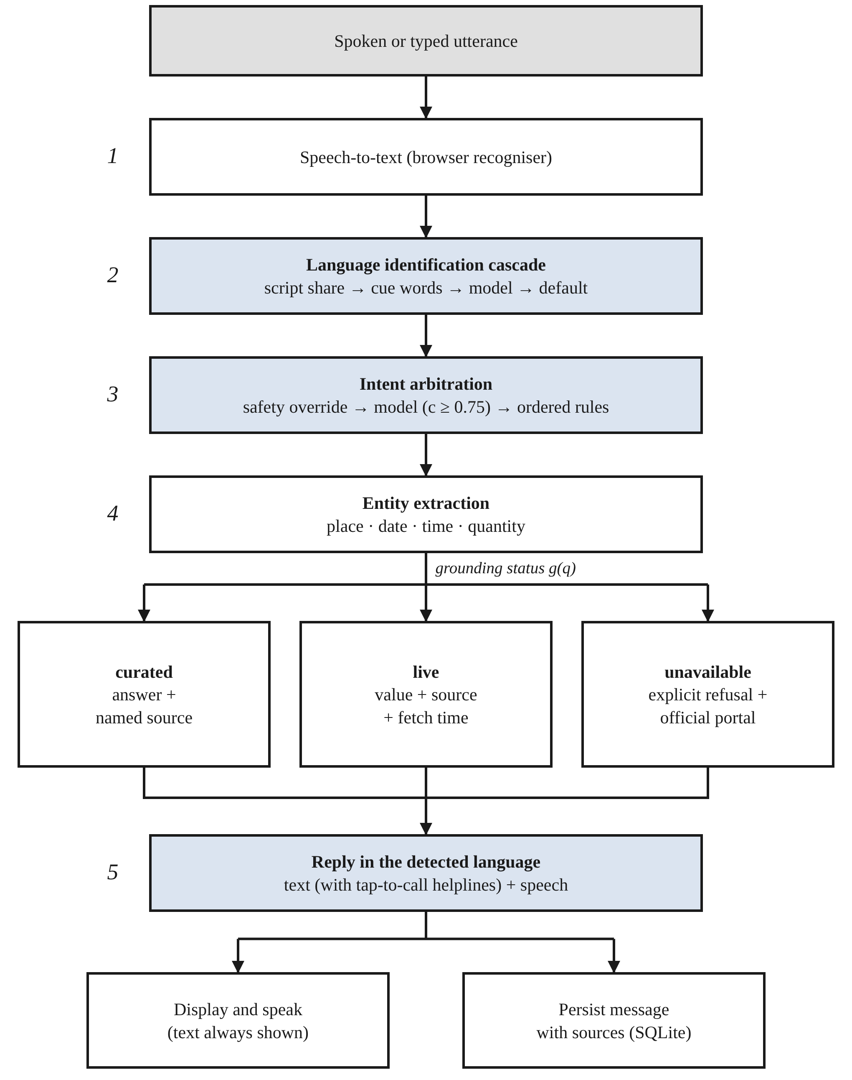
Fig. 2. Processing of a single request, from utterance to stored reply.
B. User Identity and Ownership
This step reads the request headers and produces an owner label, which then decides whose conversations, reminders and notification subscriptions the caller can see. We did not want a sign-up form standing between a first-time user and the microphone, so accounts are optional. A signed-in user sends a bearer token. A guest sends an identifier that the browser made up the first time and kept in local storage. A request with neither header, for example from a command-line test, only sees rows that have no owner at all. If u is an account and g a guest identifier, the owner of request r is
o(r) = user:u if a valid token names u;
guest:g if only g is sent;
∅ otherwise (1)
Every query on an owned table filters on o(r). One detail took some thought. When a token is sent but has expired, the server answers with HTTP 401 instead of silently treating the caller as a guest. Had it fallen back quietly, the user would have seen an empty history and assumed that their conversations were gone. When a guest signs in or registers, everything owned by guest:g moves to the account, so nothing done before signing up is lost.
C. Speech Capture and Input Handling
Input arrives either as microphone audio or as typed text, and this step turns it into a string x of at most 2,000 characters. By default the browser’s Web Speech API does the recognition, which means the audio never reaches our server. The browser recogniser listens for one locale at a time, so the user chooses the spoken language with a toggle in the header; automatic detection only happens afterwards, on the text. If Whisper is installed on the server, recorded audio can be uploaded and transcribed there instead. Typed input skips this step. We split microphone problems into three cases, namely permission refused, no microphone, and recognition service unavailable, and each gets its own message. On a screen built around a microphone, a failure that just produces silence leaves the user with no idea what went wrong.
D. Language Identification
This step takes x and returns a language label ℓ with a confidence value. The label is one of the five languages or a mixed label such as ta-en. Four tests are tried, cheapest first, and any of them may pass the decision on to the next (Table II).
Stage 1, script share. Devanagari, Tamil, Telugu and Kannada each have their own contiguous Unicode block B_{L}. For each language L in {hi, ta, te, kn}, we count the characters of x that fall in its block, and we count ASCII letters a on their own:
n_{L} = |{ t ∈ x : t ∈ B_{L} }|,
N = Σ_{L} n_{L} + a (2)
Vowel signs and the virama are counted too. An early version counted only alphabetic characters. Since these combining marks are not alphabetic, the Tamil word வானிலை (weather) counted as three letters instead of six, and that was enough to push a genuinely mixed sentence under the threshold. Let L* be the language with the highest count and s = n_{L*} / N its share. Two rules follow:
ℓ = L*, conf = 0.70 + 0.30s if s > 0.60 (3)
ℓ = L*-en, conf = 0.75
if a > 0 and 0.15 ≤ (Σ_{L} n_{L}) / N ≤ 0.60 (4)
Rule (3) handles ordinary native-script text, and a sentence written fully in Tamil gets a confidence of 1.0. Rule (4) catches sentences that really do mix an Indic script with Latin letters, and labels them as mixed instead of forcing a choice. There is a catch we should mention. Hindi is not the only language written in Devanagari (Marathi and Nepali are too), so this stage calls any Devanagari text Hindi. With our five languages that is right, but it will become wrong the day a second Devanagari language is added.
Stage 2, romanized cue words. When the text is all Latin letters, Stage 1 cannot help. Stage 2 uses a short list C_{L} of words that speakers of L use all the time and that rarely show up in English. If W(x) is the set of lower-case words in the text, each language gets the score k_{L} = |W(x) ∩ C_{L}|. Writing k₍₁₎ and k₍₂₎ for the highest and second-highest scores,
ℓ = L*-en, conf = min(0.55 + 0.10k₍₁₎, 0.85)
if k₍₁₎ > k₍₂₎ (5)
If two languages tie, or no cue word appears at all, the stage passes. A hit is reported as mixed, because in practice a few Tamil or Hindi words inside an otherwise English sentence is simply how many people write. We cap the confidence at 0.85 so that this word-list heuristic can never outrank a trained model.
Stages 3 and 4. If a fine-tuned MuRIL or IndicLID checkpoint is on disk, it is asked next. If not, the cascade just moves on. Stage 4 runs the general-purpose langdetect library and keeps its answer only when that answer is one of our five languages. When nothing has fired by the end, the text is treated as English with a confidence of 0.60.
TABLE II. Stages of the language-identification cascade
Stage | Evidence used | Answers when | Confidence
1. Script share | Unicode block counts | Indic script present | 0.70–1.00, or 0.75 if mixed
2. Cue words | Small per-language word lists | A unique language wins | 0.65–0.85
3. Model | MuRIL / IndicLID checkpoint | A checkpoint is installed | Model output
4. Statistical | General identifier (langdetect) | Label is a supported language | Identifier output
Default | None | All stages abstain | 0.60 (English)
E. Intent Arbitration and Entity Extraction
Next the system decides what the user wants (the intent, with a confidence) and pulls out typed entities. Two rules guide this step. Whether someone gets the emergency numbers should never depend on how sure a model feels. And a classifier trained on only some of the possible intents tends to be confidently wrong, not unsure, so we would rather throw away a low-confidence guess than act on it. Let S be the set of safety patterns, M a trained classifier that returns a label with confidence c, and R the rule classifier. Then
î = emergency (0.95) if x matches S;
M(x) if c ≥ 0.75;
R(x) otherwise (6)
The rule classifier works through its checks in a fixed order, and we learned the hard way that the order matters. Questions about the assistant itself go first; otherwise “where does your weather information come from?” contains the word weather and gets answered with a temperature. Keyword patterns come next. They have to run before the calculator and unit converter, which work by trying to read an expression out of the text. In one early build the order was reversed, and “remind me on 3/4/2026 to renew my passport” was treated as a division problem, so the reminder was never saved. The question bank is checked after the keyword patterns, and anything still unmatched becomes a general query. Confidence depends on how the label was reached: 0.95 for a safety match, 0.90 when a sum or conversion parses, 0.85 for a keyword pattern, 0.80 for a question-bank hit and 0.55 for the fallback.
Entity extraction then picks out places, dates, times and quantities. For a reminder, the date and time are turned into one absolute moment and saved in UTC. After that the reminder no longer depends on the sentence that created it, and it survives a page reload or a server restart.
F. Answer Sources and Source-Aware Response Policy
Every handler returns the same kind of object: the reply text, a list of sources, and a flag that says whether the reply is a refusal. A source has a title, a link and, where we know it, the date on which the information was last checked. Small talk and things the system computes itself, such as the time, a sum or a unit conversion, have no source because they say nothing about the outside world. Everything else has to carry at least one. Because the source list is part of the type, a new handler that forgets it shows up as an empty list in code review and in the tests.
We sort each query q into one of three grounding classes g(q), depending on where an answer could come from, and build the reply as
A(q) = answer + source if g = curated;
value + source + fetch time if g = live; (7)
refusal + official portal if g = unavailable
The third case is where this policy earns its keep. When a live service cannot be reached, either because no API key is set or because the call failed, the assistant says so and points the user to the official website. It never fills in a guess. Table III lists what happens in each situation.
TABLE III. Response policy by situation
Situation | What the assistant does
Identity-document question | Explains what the document is and names the issuing portal; gives no verdict on eligibility, fees or processing time
Question-bank topic | Returns the curated text in the user’s language with its source link
Weather, service reachable | Returns the reading with its source and the time it was fetched
IMD warning in force | Adds a warning line only for yellow or higher; a missing line makes no claim that conditions are safe
Mandi price, no API key | States that live prices are not switched on and points to agmarknet.gov.in
Hospital directory result | Lists names and numbers, notes that the registry is not a guarantee of service, and repeats 108
Upstream failure or unknown topic | Says it cannot answer reliably and refers the user to the authoritative portal
We chose not to answer questions about eligibility, fees or processing times at all. Those details change often, they do the most damage when mistranslated, and a citizen has no easy way to check them. The IMD warnings follow the same thinking. If access is missing, the request times out, or a warning code is one we do not recognise, the adapter returns nothing, and the reply simply has no warning line. It never says “no warnings”, because a failed request is not evidence that the weather is safe.
G. Reply Rendering and Tap-to-Call Helplines
The backend sends plain text with a few simple markers for headings, bullets and numbered steps, plus a fixed line format for helpline rows. The client turns these into proper blocks on screen, and the same code removes the markers before the text is spoken, so a screen-reader user never hears stray symbols read aloud. Helpline numbers become tap-to-call links, both in the helpline list and inside ordinary sentences.
The tricky part is that plenty of numbers in a reply are not phone numbers. “That’s 100” is the result of a sum, and ₹1930 is a price, yet 100 is also the police number and 1930 the cyber-fraud helpline. A looser rule that linked any short run of digits did exactly this once, turning a mandi price into a link to the fraud helpline, and we had to revert it. Now the client never decides on its own. Along with each reply, the backend sends the set D(q) of helpline numbers that it deliberately put in the text, and a token t becomes a link only if
link(t) ⇔ t ∈ D(q) and
t consists of 3 to 5 digits (8)
Replies from the calculator, weather and price handlers always come with an empty D. The set is saved with the message, so an old reply opened from the history drawer can still be tapped.
H. Reminder Scheduling and Delivery
A reminder matters most when the app is not open, so we deliver it in two ways. While the page is open, it asks the server for due reminders every 30 seconds. Separately, a background worker on the server wakes up every 20 seconds and sends due reminders through the browser maker’s push service, following the Web Push protocol [23] with messages signed by a VAPID key pair [24]. The service worker in the browser then shows a system notification. If the app happens to be open and visible, it passes the reminder to the page instead, so the usual in-app alert and spoken reminder appear. To make sure a reminder m with due time d(m) fires only once, both paths use the same test at time t:
deliver(m, t) ⇔ d(m) ≤ t and
notified(m) = ∅; then
notified(m) ← t (9)
Whichever path gets there first marks the reminder as sent. One security point came up here. A push subscription includes an endpoint URL that the browser supplies and that our server later sends requests to. Left unchecked, anyone could use this to make the server contact any address they liked. So we only accept endpoints that belong to the push services run by Google, Mozilla, Microsoft and Apple. If no VAPID keys have been configured, the server creates a pair on first use and stores it outside version control, which means a fresh copy of the project works without any setup.
I. Persistence and Schema Migration
Each saved message keeps its text together with the detected language, intent, entities, sources and dialable numbers. When someone reports a wrong answer about a government scheme or a hospital, the first thing anyone wants to know is where it came from, and the stored record answers that. Table IV lists the main tables.
TABLE IV. Core database entities
Entity | Purpose | Relationship
User | Optional account with a scrypt password hash | Has many sessions and owned rows
AuthSession | Sign-in, keyed by the SHA-256 of its token | Belongs to one user
Conversation | One thread of related messages | Owned by a user, a guest or no one
Message | Text, NLU trace, sources and dialable numbers | Belongs to one conversation
Reminder | Request text, due instant, delivery state | Owned like a conversation
PushSubscription | One browser that accepted notifications | Owned like a conversation
Before this version, a hand-written routine patched missing columns into old databases. We replaced it with Alembic. The first migration is written so that it can take over a database created before migrations existed, and migrations run automatically when the server starts. A new install, an old database and an up-to-date one all end up on the current schema without anyone running a command.
IV. Implementation
This section describes the prototype as it runs today; Figs. 3–5 show the interface. We only call something implemented if it has been exercised, either by the automated tests or by running the app. Code that has never talked to its real external service is marked as unverified.
A. Frontend
The client is a React 18 app built with Vite 5. It uses axios for HTTP, framer-motion for animation and lucide-react for icons, with plain CSS and no router or state library. The home screen (Fig. 3) is centred on a large orb: tap it and it starts listening. A smaller “Type instead” button opens a text box. The header holds the language toggle, a switch for spoken replies, the reminders panel and a light/dark theme switch. Once a reply comes in, the home screen shows it in a card under the orb together with its source links. The full conversation view (Fig. 4) shows every turn along with the detected language and the intent and entities that were found. We kept this visible on purpose, because it makes the pipeline easy to follow for users and for anyone reviewing the system.
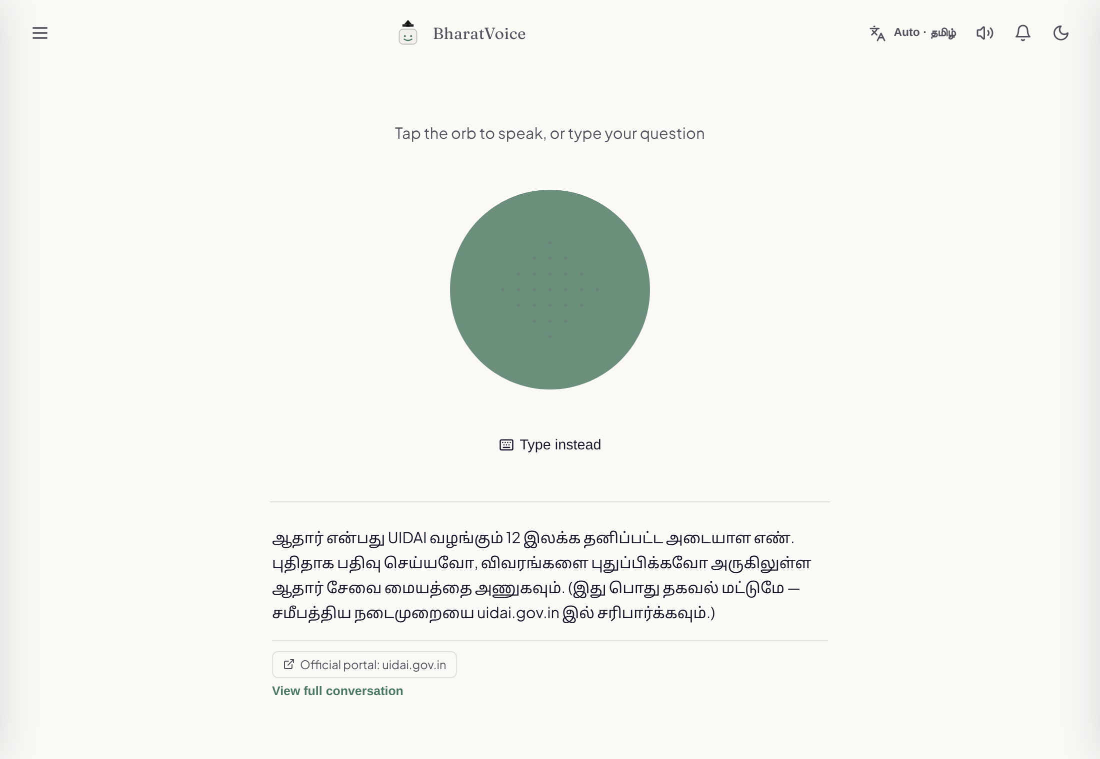
Fig. 3. Home screen after a question typed in Tamil script, showing the reply in Tamil and the official-portal source link.
If there is no voice for the reply language on the device or on the server, a short note says so and the full text stays on screen. The text is always shown, whether or not speech works.
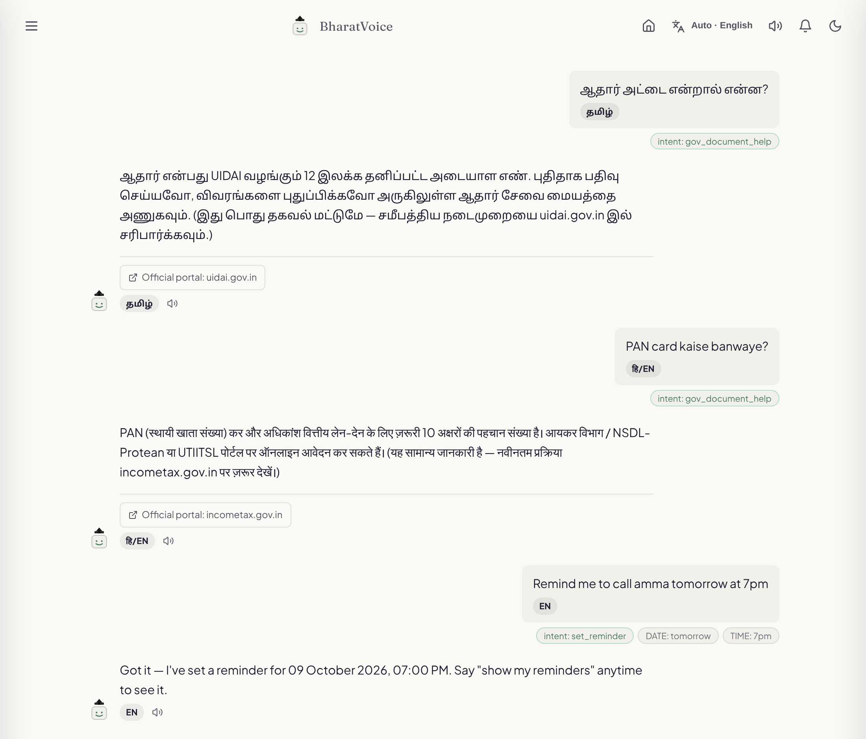
Fig. 4. Conversation view: a Tamil-script document question, a romanized Hindi–English question about the PAN card answered in Hindi with its official-portal link, and an English reminder request with the date and time it extracted.
B. Backend
The backend uses Python 3.12, FastAPI 0.115, Pydantic 2 and SQLAlchemy 2, and runs under uvicorn. There are routers for chat, speech, language, intent, translation, history, reminders, accounts and push subscriptions. Everything in Section III goes through the chat route. It resolves the owner, runs language identification, intent arbitration and entity extraction through a single orchestration module, calls the right handler, applies the response policy, saves the exchange and sends it back. We kept the local skills small and careful. The calculator is a good example: instead of handing the text to a general evaluator, it walks a restricted syntax tree with a fixed list of allowed operators, refuses expressions longer than 120 characters, and caps the size of the result.
C. Content
The curated content covers six identity documents (Aadhaar, PAN, voter ID, ration card, passport and driving licence), nine emergency helplines, and 18 question-bank topics spread over seven areas: education, banking, scam awareness, travel, welfare schemes, jobs and health facilities. Every answer exists in all five languages. Hindi, Telugu and Kannada strings that no native speaker has checked yet are flagged in the source code. When the assistant is asked which languages it supports, it builds the answer from a status table in the code instead of a hand-written paragraph, so what it says about itself stays in step with the real state of the project.
D. Live Data Adapters
Weather comes from Open-Meteo [25], which needs no key, and if a place name is ambiguous the assistant asks which one the user meant. Mandi prices come from the AGMARKNET dataset on the Open Government Data platform [26] and need a free API key. District warnings from the India Meteorological Department [27] are added to weather answers once IMD access has been set up. Hospital lookups use the National Hospital Directory on the same data platform. The four adapters follow one rule when something goes wrong: a missing key, a timeout, an HTTP error, a response in an unexpected shape or an empty result all come back as “nothing”, and the response policy turns that into a refusal or simply leaves the extra line out. We should be clear about what has been checked. The IMD and hospital adapters were written from the published documentation and have not yet been run against the live services, and the mandi field names have not been confirmed against a successful live response. We treat all three as implemented but unverified.
E. Accounts and Notifications
Passwords are hashed with scrypt [28], which ships with Python’s standard library. A session token is a random string that the client receives once. The server keeps only its SHA-256 hash, so a copy of the database cannot be used to log in as anyone. Sessions expire after 30 days. Every request carries either the token or the guest identifier. Users turn on reminder notifications from the reminders panel; this registers the service worker, asks the browser for permission and sends the push subscription to the server. Fig. 5 shows the helpline reply, where each number is a row that can be tapped to call.
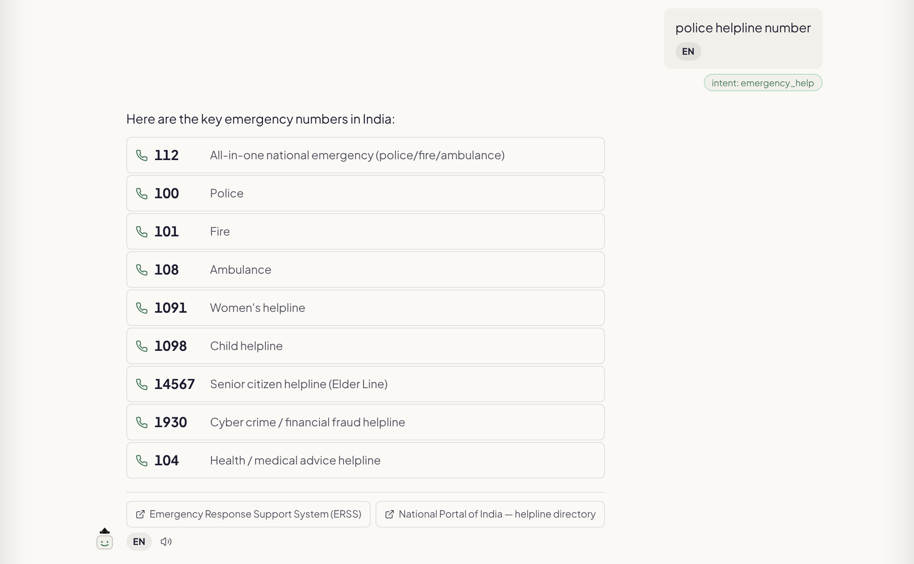
Fig. 5. Emergency helpline reply with tap-to-call numbers and source links.
F. Build, Test and Deployment
On Windows, one script starts the backend on port 8000 and the frontend on port 5173. The project can also run under Docker Compose, with nginx serving the built frontend. Backend tests use pytest and the Python code is checked with ruff. Frontend tests use Vitest and Testing Library, and the frontend is checked with ESLint. A GitHub Actions workflow runs the tests, both linters and a production build on every push.
V. Evaluation Methodology
We separate what has already been checked from what still needs to be measured. Subsections A and B describe work that has been done. Subsections C to F describe evaluations we plan to run, and we make no claims about their outcome.
A. Software Verification
The backend has 693 automated tests and the frontend has 45. All of them pass on the current development branch, and Table V breaks the backend tests down by module. Between them, the tests cover reply selection by language, whether translated content exists for every language, refusals, separation between accounts and guests, migration of old databases, one-time delivery of reminders, rejection of push endpoints outside the allowed services, and the rule that only numbers marked by the server become links. Three of the tests exist only to keep the languages in step: every helpline label must have a translation, every identity-document explanation must have one, and document replies must really differ by language instead of quietly falling back to English.
TABLE V. Automated backend test suite
Module | Tests | Result
Self-description of the assistant | 265 | Pass
Curated question bank | 159 | Pass
Core pipeline and skills | 116 | Pass
Voice input and output | 35 | Pass
Helplines and IMD warnings | 33 | Pass
Accounts and ownership | 31 | Pass
Push delivery | 29 | Pass
Hospital lookup | 19 | Pass
Schema migrations | 6 | Pass
Total | 693 | All passing
Passing tests tell us the code does what we designed it to do. They tell us nothing about how often the system understands a real person. The IMD and hospital tests, for example, use recorded or hand-built responses rather than the live services.
B. Informal Probe of Romanized and Code-Mixed Input
To get a feel for behaviour outside the test suite, we typed a handful of romanized and code-mixed questions into the running prototype and noted the language and intent it returned (Table VI). This was one pass over nine questions that we wrote ourselves. It shows the kinds of mistakes the system makes; it is not a sample of real users and it is not an accuracy figure.
TABLE VI. Informal probe with romanized and code-mixed queries
Query (meaning) | Language | Intent | Outcome
PAN card kaise banaye (how to get a PAN card) | hi-en | Document help | Correct, reply in Hindi
Chennai la weather epdi irukku? (weather in Chennai) | ta-en | Weather | Correct; refused while service was unreachable
kal Delhi mein mausam kaisa rahega (weather tomorrow) | hi-en | General query | Language right, intent missed
naalaikku Madurai la mazhai varuma (rain tomorrow) | en | General query | Both missed
Bengaluru alli hawamana hege ide (weather in Bengaluru) | en | General query | Both missed
mujhe bachao, aag lagi hai (help, there is a fire) | hi-en | General query | Emergency missed
police helpline number | en | Emergency | Correct, helpline list
tomato mandi price | en | Mandi price | Correct; refused, no key
remind me tomorrow at 9 am to pay electricity bill | en | Reminder | Correct, 09:00 next day
The probe turned up three clear weaknesses. First, the weather patterns do not include romanized words like mausam, mazhai or hawamana, so a weather question is only understood when it uses the English word. Second, romanized Tamil and Kannada that contain none of our cue words fall through to langdetect, which either guesses English or guesses a language we do not support, and that is then relabelled as English. Third, and most worrying, a romanized Hindi cry for help with no English keyword in it was not caught by the safety patterns. While checking reminders we also found that “காலை 9” (kaalai, Tamil) and “सुबह 9” (subah, Hindi), both meaning nine in the morning, were set for 9 p.m. These are the first fixes listed in Section VIII.
C. Language-Identification Accuracy
We will build a labelled test set with native-script, romanized and code-mixed sentences in each of the five languages. The sentences will be written by native speakers who have not seen our cue-word lists. We will report accuracy for each language and each writing style,
Accuracy_{LID} = (N_{correct} / N_{total}) × 100% (10)
along with a confusion matrix and how often each stage of the cascade passes. The same set will be used to compare the rule cascade with a fine-tuned MuRIL model; the script for that comparison is already written.
D. Intent Routing and Refusal Behaviour
A second set will mix questions the system should be able to answer with questions it has no reliable source for, each labelled with the route it ought to take. Routing accuracy will be computed as in (10). Refusals need two numbers, since refusing too seldom and refusing too often are both problems. If U is the set of unanswerable questions and F the set the system actually refused,
Refusal recall = |F ∩ U| / |U|,
Refusal precision = |F ∩ U| / |F| (11)
Emergency requests, including romanized and code-mixed ones, will be reported on their own. Missing one of those is worse than missing many ordinary questions.
E. Speech Recognition
We will measure speech recognition with real microphones on at least two common Android phones and one laptop, in every language, using the word error rate
WER = (S + D + I) / N (12)
where S, D and I count substitutions, deletions and insertions against a reference transcript of N words. Where a server-side recogniser is available, it will be tested under the same conditions as the browser one.
F. Native-Speaker Review and Usability
Roughly 190 Hindi, Telugu and Kannada strings are flagged in the code as not yet reviewed. Native speakers will rate each one for correctness and naturalness. We will also check the nine helpline numbers against the official portals and record the date of each check. Finally, a small task-based study with first-time users, including older people and screen-reader users, will record which tasks they finish and where they give up.
VI. Discussion
A. Architectural Implications
The biggest choice we made was to leave out a generative model and allow the assistant to refuse. For the questions BharatVoice is meant for, this pays off. Every factual sentence a user sees was either written and checked beforehand or came from a named live source, and the saved record shows which. When an answer is wrong, we can find out why by reading that record instead of guessing what a large model was doing. The price is coverage. A question outside our patterns gets a request for more detail or a refusal, where a generative system would at least try.
The cascade and the intent arbiter work like Chow’s reject option [20], [21]. Each stage answers only when its evidence is strong and otherwise hands the decision on. For native script this works well: Stage 1 is exact, so most native-script input never needs a model. The probe in Section V-B shows the weak side. When the cheap stages pass and no trained model is installed, what is left is not good enough, and romanized Tamil and Kannada suffer the most.
B. Trade-offs
Refusing is safer than guessing here, but it has a cost. A user may find a refusal less useful than a rough answer, and if refusals come too often, people will stop asking. That is why refusal precision is part of the plan in (11). Limiting document answers to what a document is and where to get it makes the answers less complete, but the details we leave out are the ones most likely to be out of date.
Accounts and notifications bring trade-offs of their own. Optional sign-in, with guest history carried over, keeps the first visit simple, but the system now stores personal history and has to protect it. Push delivery depends on the browser makers’ push servers and on our server running at the due time; a laptop that is asleep gets the notification when it wakes up. Recognising speech in the browser keeps audio off our server and avoids the need for a GPU, but quality varies with the browser and device, and only one language can be heard at a time.
C. Limitations
There are several gaps. We have not measured recognition accuracy for any language, either for text or for speech, so everything claimed here is about design and tested software behaviour. Intent detection is rule-based and, as the probe showed, misses romanized words, including a romanized Hindi call for help. Morning times given in Tamil or Hindi words were scheduled for the evening. The translation fallback only covers Tamil and English, and about 190 Hindi, Telugu and Kannada strings still need a native speaker to review them. The mandi, IMD and hospital adapters have not been confirmed against live responses, and the helpline numbers have not been re-checked against the official sites. Accounts have no password reset and no limit on sign-in attempts, so the system should not be put on the public internet as it stands. Conversations saved before accounts existed have no owner and do not appear in the app until they are attached to an account. Finally, we have not yet tested the system with real users, on a range of real devices, or with screen readers.
VII. Conclusion
We have described BharatVoice AI, a voice-first assistant for everyday needs in Tamil, Hindi, Telugu, Kannada and English. It runs on ordinary hardware and refuses when it has no source. Language is identified by a cascade that is exact for native script and passes when it is unsure, emergency requests are handled before any classifier, and each factual answer comes with its source. The version reported here adds optional accounts with per-user history, versioned database migrations, reminders that arrive after the page is closed, and helpline numbers that can be tapped to call, with a server-side rule that stops prices and sums from turning into phone links.
All 693 backend tests and 45 frontend tests pass. That tells us the software behaves as designed, but not how well it understands the people it is meant for. Our small probe already showed where the rule-based stages struggle with romanized input. Our next steps are to fix those problems, run the measurements planned in Section V, and publish accuracy figures for each language.
VIII. Future Work
We plan the following work. None of it is in the current code.
- Add romanized and code-mixed emergency phrases to the safety patterns, and test them separately
- Recognise romanized weather and price words such as mausam, mazhai and hawamana
- Read morning and evening words (kaalai, subah, maalai, shaam) when parsing reminder times
- Fine-tune MuRIL for language identification and intent, and compare it with the rule cascade on the test set of Section V-C
- Move speech recognition to a server-side model through BHASHINI or Whisper, so the spoken language can be detected from the audio
- Finish native-speaker review of the Hindi, Telugu and Kannada replies, and re-check every helpline number
- Confirm the mandi, IMD and hospital adapters against live responses
- Add password reset and limits on sign-in attempts before any public deployment
Along with the measurements in Section V, this work would let us report how accurate the system is, and not only how it is designed.
References
[1] I. Medhi Thies, “User interface design for low-literate and novice users: Past, present and future,” Foundations and Trends in Human–Computer Interaction, vol. 8, no. 1, pp. 1–72, 2015.
[2] J. Zhou, R. Shen, Y. You, C. DiSalvo, L. Dombrowski, and C. MacLellan, “Improving public service chatbot design and civic impact: Investigation of citizens’ perceptions of a metro city 311 chatbot,” arXiv:2506.12259, 2025.
[3] A. Radford, J. W. Kim, T. Xu, G. Brockman, C. McLeavey, and I. Sutskever, “Robust speech recognition via large-scale weak supervision,” in Proc. Int. Conf. Machine Learning (ICML), PMLR, vol. 202, 2023, pp. 28492–28518.
[4] T. Javed, S. Doddapaneni, A. Raman, K. S. Bhogale, G. Ramesh, A. Kunchukuttan, P. Kumar, and M. M. Khapra, “Towards building ASR systems for the next billion users,” in Proc. AAAI Conf. Artificial Intelligence, vol. 36, no. 10, 2022, pp. 10813–10821.
[5] K. S. Bhogale, S. Sundaresan, A. Raman, T. Javed, M. M. Khapra, and P. Kumar, “Vistaar: Diverse benchmarks and training sets for Indian language ASR,” in Proc. INTERSPEECH, 2023, pp. 4384–4388.
[6] T. Javed, J. A. Nawale, E. I. George, et al., “IndicVoices: Towards building an inclusive multilingual speech dataset for Indian languages,” in Findings of the Association for Computational Linguistics: ACL 2024, 2024.
[7] S. Khanuja, D. Bansal, S. Mehtani, S. Khosla, A. Dey, B. Gopalan, et al., “MuRIL: Multilingual representations for Indian languages,” arXiv:2103.10730, 2021.
[8] D. Kakwani, A. Kunchukuttan, S. Golla, G. N. C., A. Bhattacharyya, M. M. Khapra, and P. Kumar, “IndicNLPSuite: Monolingual corpora, evaluation benchmarks and pre-trained multilingual language models for Indian languages,” in Findings of the Association for Computational Linguistics: EMNLP 2020, 2020, pp. 4948–4961.
[9] S. Doddapaneni, R. Aralikatte, G. Ramesh, S. Goyal, M. M. Khapra, A. Kunchukuttan, and P. Kumar, “Towards leaving no Indic language behind: Building monolingual corpora, benchmark and models for Indic languages,” in Proc. 61st Annu. Meeting of the Association for Computational Linguistics (ACL), 2023.
[10] J. Gala, P. A. Chitale, R. AK, V. Gumma, S. Doddapaneni, et al., “IndicTrans2: Towards high-quality and accessible machine translation models for all 22 scheduled Indian languages,” Transactions on Machine Learning Research, 2023.
[11] Ministry of Electronics and Information Technology, Government of India, “Digital India BHASHINI: National Language Translation Mission,” 2022. [Online]. Available: https://bhashini.gov.in
[12] Y. Madhani, M. M. Khapra, and A. Kunchukuttan, “Bhasha-Abhijnaanam: Native-script and romanized language identification for 22 Indic languages,” in Proc. 61st Annu. Meeting of the Association for Computational Linguistics (Short Papers), 2023.
[13] S. Khanuja, S. Dandapat, A. Srinivasan, S. Sitaram, and M. Choudhury, “GLUECoS: An evaluation benchmark for code-switched NLP,” in Proc. 58th Annu. Meeting of the Association for Computational Linguistics (ACL), 2020, pp. 3575–3585.
[14] B. R. Chakravarthi, V. Muralidaran, R. Priyadharshini, and J. P. McCrae, “Corpus creation for sentiment analysis in code-mixed Tamil-English text,” in Proc. Joint Workshop on Spoken Language Technologies for Under-resourced Languages (SLTU) and Collaboration and Computing for Under-Resourced Languages (CCURL), LREC, 2020.
[15] Z. Ji, N. Lee, R. Frieske, T. Yu, D. Su, Y. Xu, E. Ishii, Y. J. Bang, A. Madotto, and P. Fung, “Survey of hallucination in natural language generation,” ACM Computing Surveys, vol. 55, no. 12, art. 248, 2023.
[16] P. Lewis, E. Perez, A. Piktus, F. Petroni, V. Karpukhin, N. Goyal, et al., “Retrieval-augmented generation for knowledge-intensive NLP tasks,” in Advances in Neural Information Processing Systems, vol. 33, 2020, pp. 9459–9474.
[17] H. Rashkin, V. Nikolaev, M. Lamm, L. Aroyo, M. Collins, D. Das, S. Petrov, G. S. Tomar, I. Turc, and D. Reitter, “Measuring attribution in natural language generation models,” Computational Linguistics, vol. 49, no. 4, pp. 777–840, 2023.
[18] J. FitzGerald, C. Hench, C. Peris, et al., “MASSIVE: A 1M-example multilingual natural language understanding dataset with 51 typologically-diverse languages,” in Proc. 61st Annu. Meeting of the Association for Computational Linguistics (ACL), 2023.
[19] Y. Madhani, S. Parthan, P. Bedekar, G. N. C., et al., “Aksharantar: Open Indic-language transliteration datasets and models for the next billion users,” in Findings of the Association for Computational Linguistics: EMNLP 2023, 2023.
[20] C. K. Chow, “On optimum recognition error and reject tradeoff,” IEEE Transactions on Information Theory, vol. 16, no. 1, pp. 41–46, Jan. 1970.
[21] Y. Geifman and R. El-Yaniv, “Selective classification for deep neural networks,” in Advances in Neural Information Processing Systems, vol. 30, 2017.
[22] P. S. Varadhan, A. Sankar, G. Raju, and M. M. Khapra, “Rasa: Building expressive speech synthesis systems for Indian languages in low-resource settings,” in Proc. INTERSPEECH, 2024.
[23] M. Thomson, E. Damaggio, and B. Raymor, “Generic event delivery using HTTP push,” IETF RFC 8030, Dec. 2016.
[24] M. Thomson and P. Beverloo, “Voluntary application server identification (VAPID) for web push,” IETF RFC 8292, Nov. 2017.
[25] Open-Meteo, “Weather forecast API documentation.” [Online]. Available: https://open-meteo.com/en/docs
[26] Government of India, “Open Government Data (OGD) Platform India.” [Online]. Available: https://data.gov.in
[27] India Meteorological Department, “Mausam: District-wise weather warnings.” [Online]. Available: https://mausam.imd.gov.in
[28] C. Percival and S. Josefsson, “The scrypt password-based key derivation function,” IETF RFC 7914, Aug. 2016.

